Do’oma site-specific topic: Research Officer observations record
Shiferaw Neda
Nurtrition programme for babies 6-18 months 1
Bridge-building 2
Electricity 3
Water harvesting 4
Modern beehives 5
Malaria and the use of bednets 5
Maize failure due to pests 6
Migrant farmers using pesticides 7
Motorbike transport for hire 7
Case stories 8
Case story of Mrs. N a potter 8
Case story of farmer with injured calf 9
Cases of use of mobile phones 10
Meskel Holiday Events 10
Research officers experience of the celebrations 11
Nutrition programme for babies 6-18 months
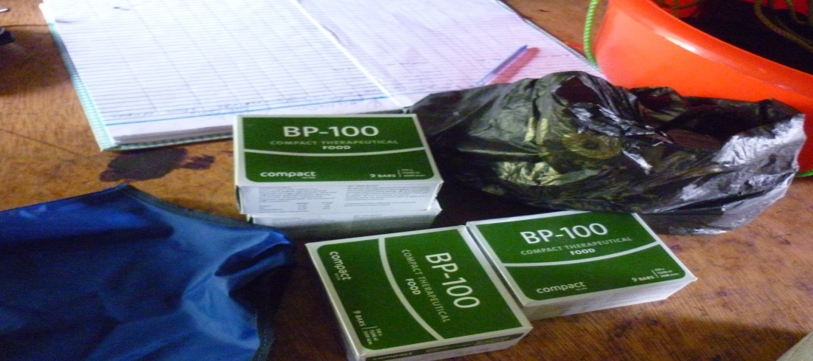
While working in the kebele compound, I encountered a nutrition programme going on by which babies 6-18 months are given supplementary food called BP-100 /Plumpy nut, donated by Fhi (Family Health International), to the wereda. The health extension workers were trained and the actual service began just at the time of the field work in September 2011, by which time the first round beneficiaries were being served. At the kebele level/health post level, babies whose weight is greater than four kg. and whose arm rounds is about 12 centimeter. If their weight and arm measures are less than what is mentioned above, they will be referred to the health centre at the wereda town/ Wacha for special treatment.

The BP-100 in its pack

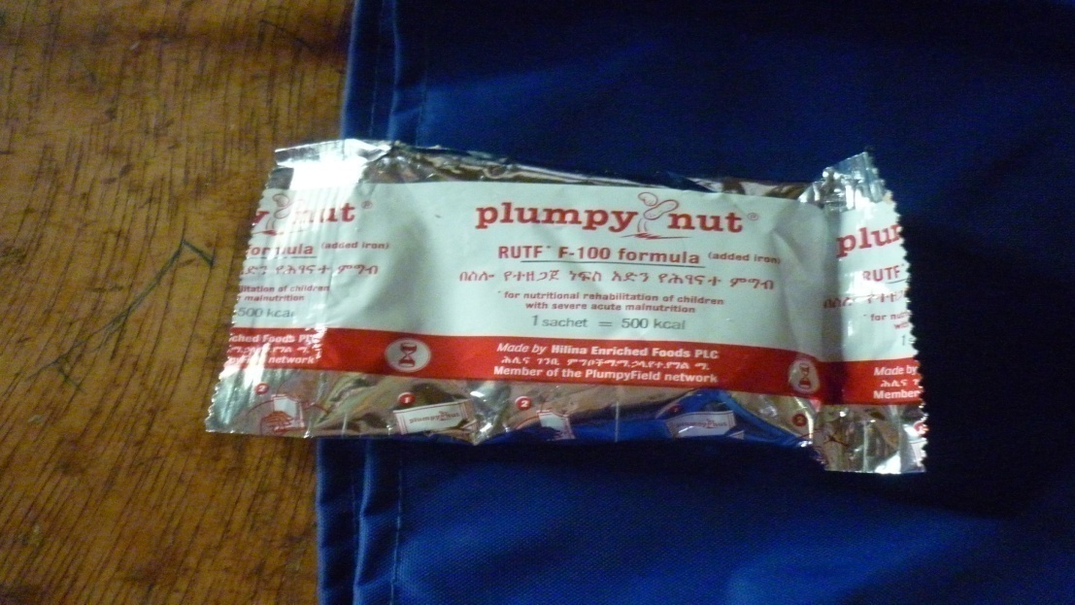
The supplement out of the pack
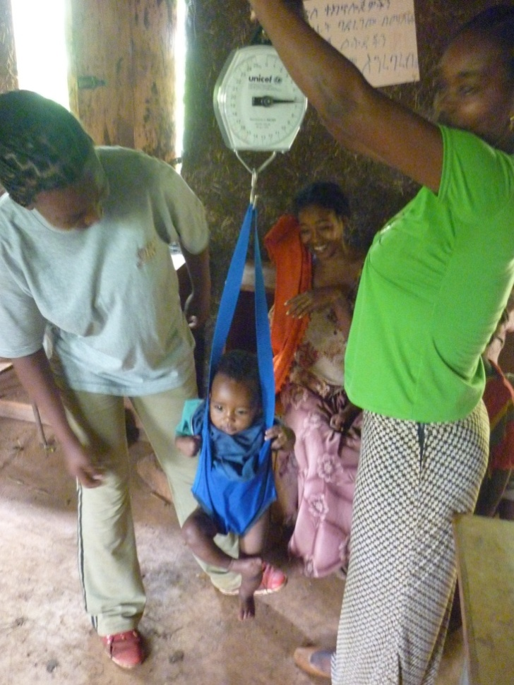
Picture showing the weight measurement

Bridge-building
As its described on earlier studies, Do’oma kebele/ Deramalo Wereda remained disconnected in every summer as the two main rivers Zage and Domba block them. However recently a new bridge was completed on Zage river and the bridge on Domba river is in progress, all the basement completed and the construction workers said that the rest is so easy which may take one month intensive work. At the moment, the motor bikes and vehicles can pass Zage bridge with full comfort though it seems a challenge for the bikes and people who want to cross the Domba river whose bridge is not yet done. The pictures below shows the bridges and motorbikes crossing Domba river.
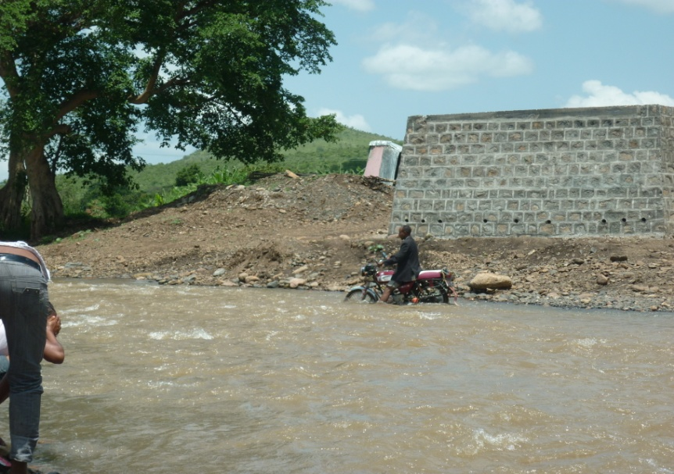
Motor bikes crossing Domba river, and the bridge under construction.
The motorbikes are transporting people from Moka to Wacha, but here, the passenger should cross the river and use the bike on the other side.
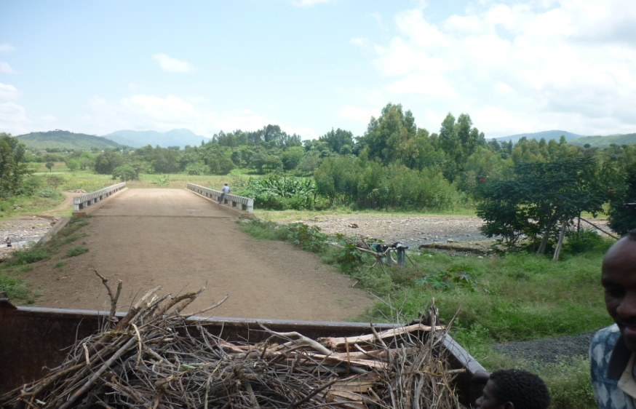
Newly completed bridge on Zage river

Electricity
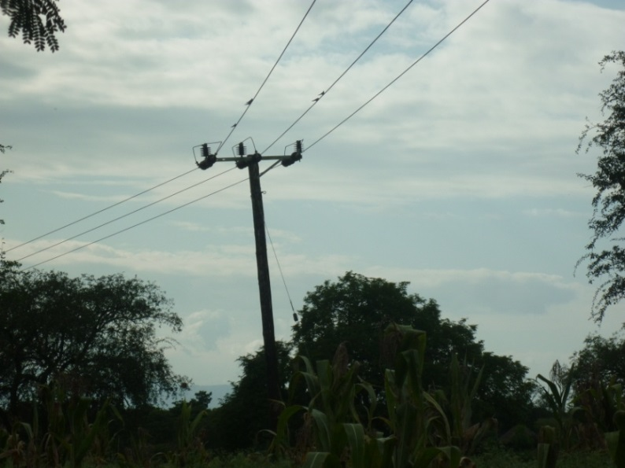
In 2002, the wereda office made Do’oma kebele households, to contribute 30 birr per household, through the kebele administration to provide them with electricity, everyone contributed with great passion to see electric light. The project made all the kebele wired including the sub-kebele Womala. However, it is not powered yet and even no wire is distributed in any of the households so far which raises lots of complaints about the kebele administration from the community. The picture bellow shows the wire passing through the village.

The new electric line in Do’oma which is not powered

The electric wire passing through the villages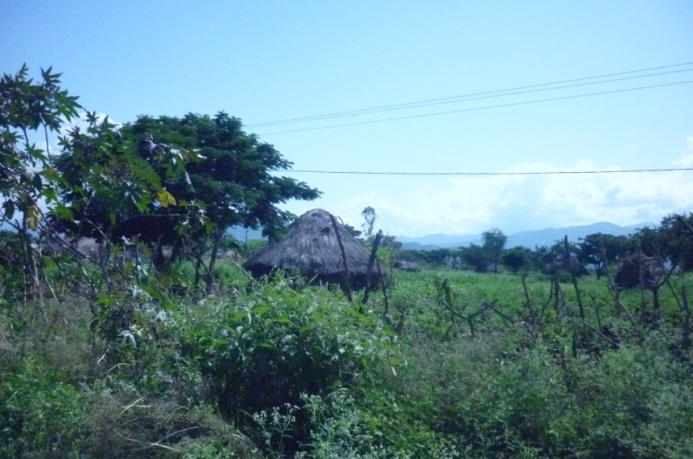

Water harvesting
The water harvesting was introduced as one of the solution for the rainfall shortage in the area. The plastic was distributed to model farmers, from which interested neighbours were also meant to share the water. However, the programme didn’t go far to succeed as it was hoped. Whenever I move to the village, I have seen the plastic meant for water harvesting being used for other purposes, and the holes dug for the water left without the plastic and grass grown over them except the one in the kebele compound on which the grass covered the hole over the plastic.
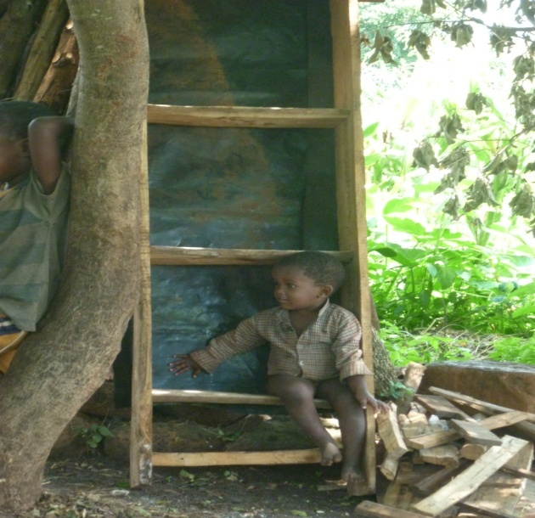
Water harvesting plastic used for shelf back as the baby indicates
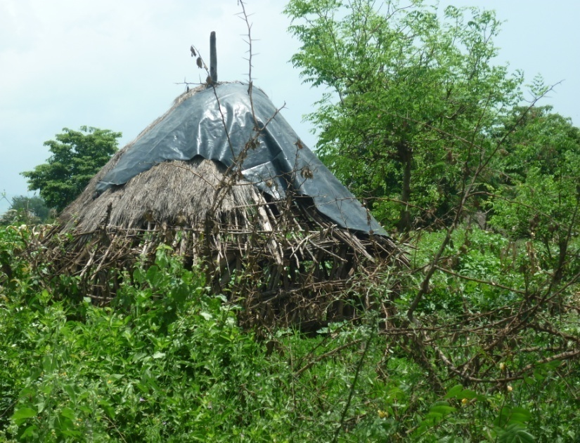
The plastic covering roof of the Kebele vice chairman livestockhouse

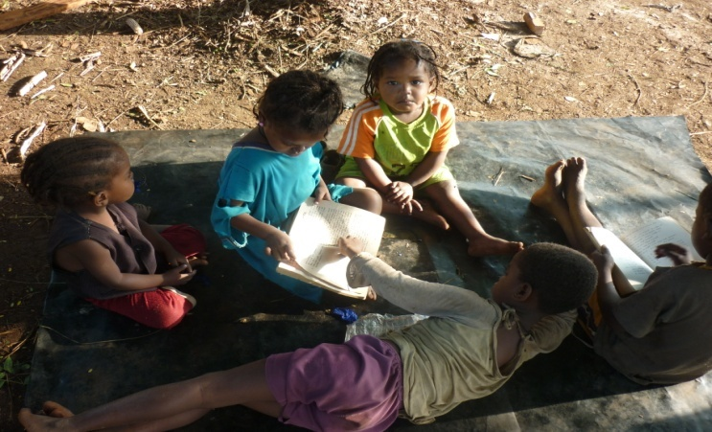

The plastic as a carpet for children to study

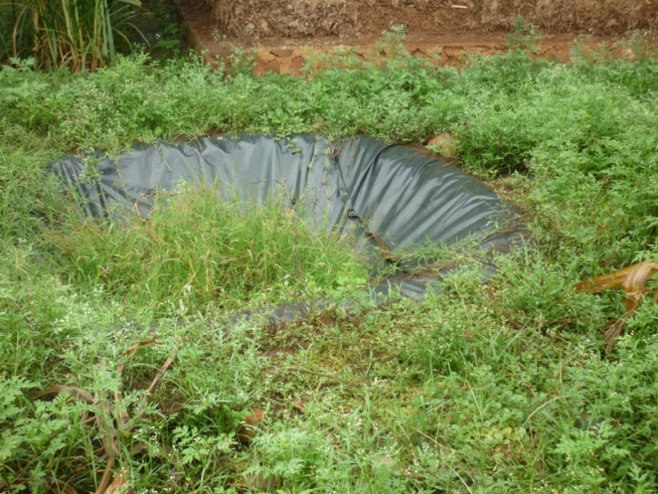

The water harvesting sample in front of farmers’ training centre

Modern beehives
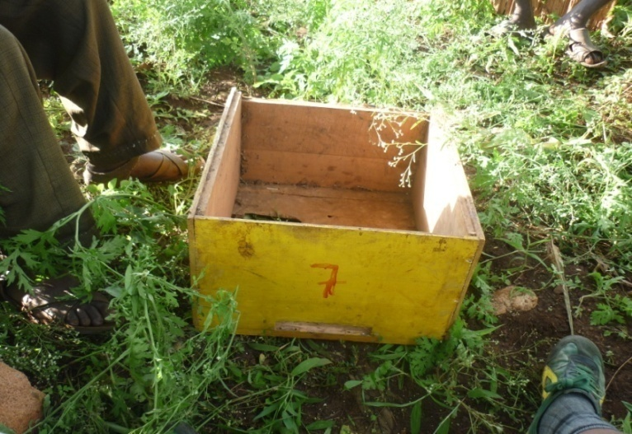
While doing interviews, I saw the inner part of modern bee hives which is made of wood and fiber, I asked about it and I found out that, there has been communal beehives donated by UNICEF in 1978 during the Derg regime, the benefit from the honey product to trickle down to the villagers through wereda administration. However after the EPRDF took power, this communal bee keeping was demolished and the land was given to individuals for farming and the bee hives were taken to the kebele office which we were provided as a chair to sit on under a tree while doing the interviews. One of our respondents was trying to make traditional bee hives though the people in community were not using his cheap product very well which is 3.50 birr only. He mentioned as he wants modern bee hives which he felt unaffordable and keeps bees within 12 traditional beehives he made. The remains of the old bee hives are shown in the picture.

One of the boxes that is stored in the kebele office

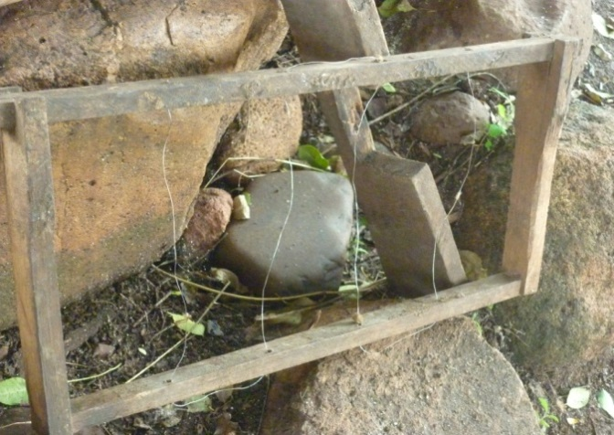
The inner part of the bee hives found in one the villagers’ houses.

Malaria and the use of bednets
Do’oma is a site where malaria is known to be a threat to the community, though the distribution of bed nets are mentioned as having full coverage; however the attitude towards it seems far behind. Male respondents said that health extension workers should check as it has been used or abandoned by moving to every house. Their main concern was the lack of malaria treatment tablet what they call it kuartum, in fact one of the female respondent even said that bed nets doesn’t save them from malaria since they are being affected while using the net.
When I we move in to the villages, we saw that the bed net is used differently outside the home like covering the chicken’s house and also to use on the fence construction of the kebele office as the pictures show below. From informal talk, I found out that people don’t like the rectangular bed net, and whenever they are given this type of net, they use it as rope for fence construction. If circular bed nets are distributed, though people don’t seriously believe in bed nets’ protection they usually use them.
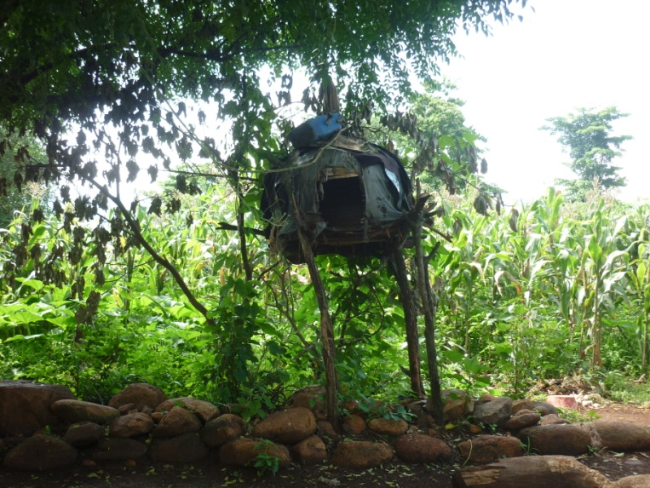
Bed net used for covering chicken house

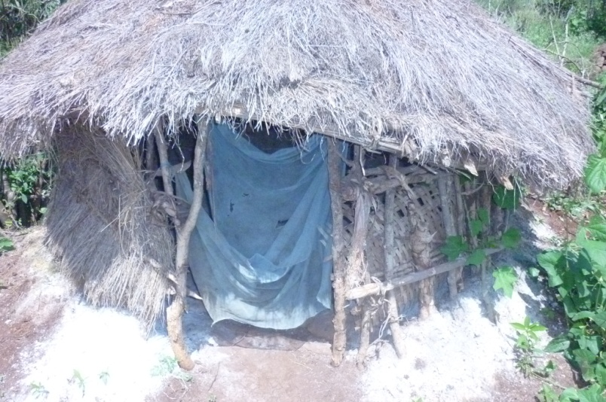
Toilet with bed net door

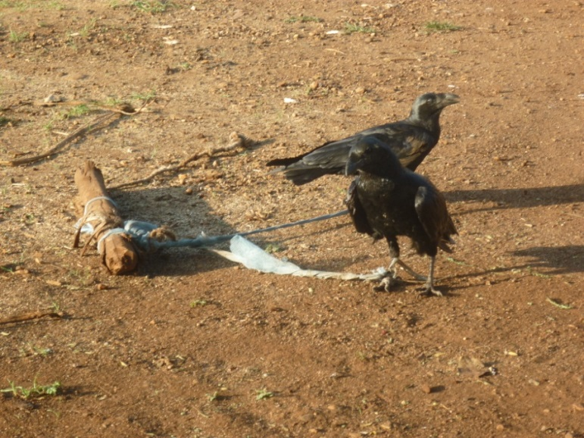
Disturbing birds tied with bed net, in one of the hotel in Deramalo/ Wacha
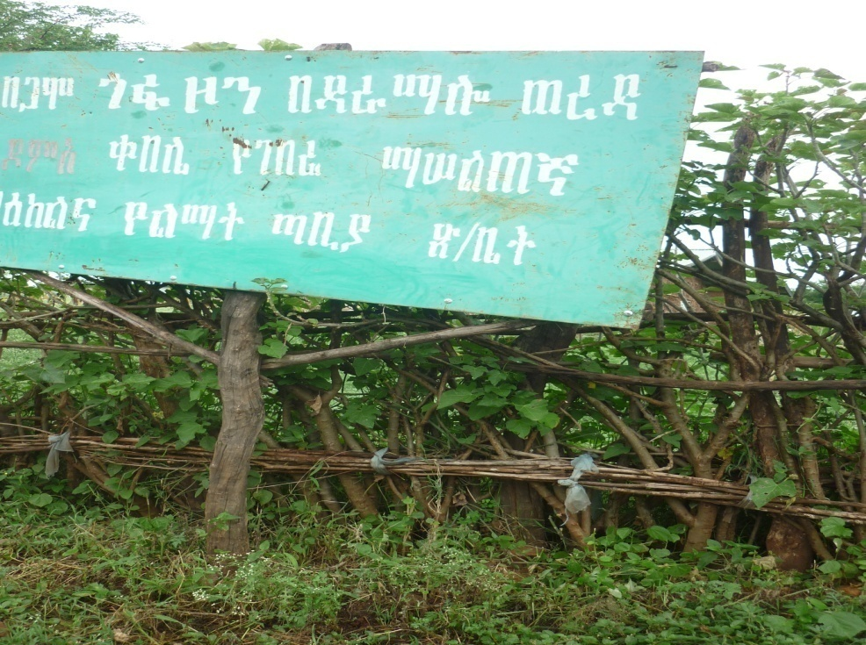
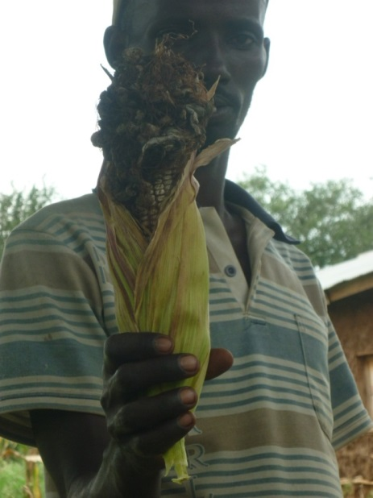
Bed nets used as rope to fasten the woods on the kebele office fence

Maize failure due to pests
Participants in one of the interview session raised the issue of pests and crop failure which is recently becoming an issue in addition to the rainfall shortage that is the common reason for failure of maize product (the main product). In 2011 the maize is begun to be spoiled as shown on the picture.

Migrant farmers using pesticides
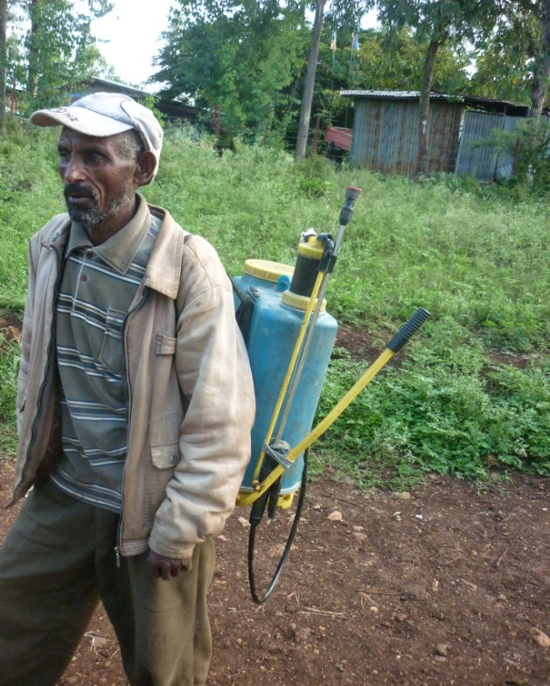
The issue of innovative migrants in the area was found out through informal discussion with one migrant from north Ethiopia in to the village. I encountered the person when he is back from his Onion farm after spraying pesticides. He told me as he saw some pests affecting his plant and sprayed pesticide he bought by himself. When he was talking to me his fellow migrant came and they began to discuss about another concern about their pepper plant which is also being affected by pests which is new for them, the new comer suggested pest that is used for other crop, and the person on the picture below said that the pesticide suggested was strong and could kill the plant as well, their conversation shows their confusion, and he told me that he was thinking to consult the DAs, but he said that the DAs in the area doesn’t know details about these new crops to the area like Onions, peppers, sesame, chick beans, etc. Finally I forwarded my good wish to them and departed.

The Migrant Amhara farmer in Do’oma

Motorbike transport for hire
Transportation from Do’oma kebele to Wacha town/Deramalo Wereda is usually on foot, however people sometimes use motorbikes that carry two passengers by paying ten birr per trip. The road is not good for the even for the bikes if it rained that add water on irrigation outlets.
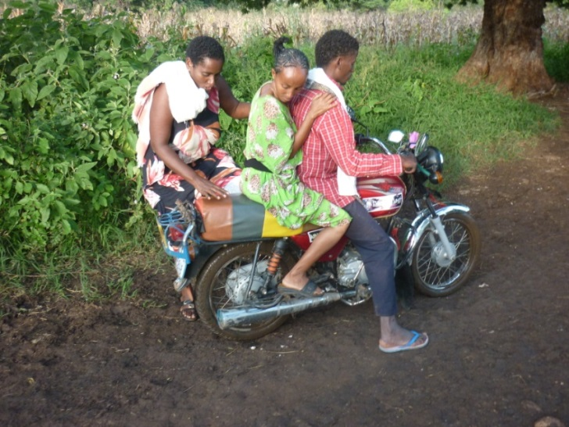
Motorbikes as transportation from kebele to the wereda/ Wacha

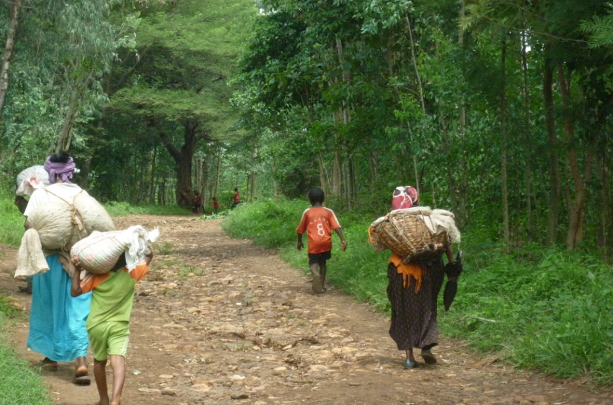
People walking to Wacha market which s on Thursday and Saturday.

Kebele/wereda deductions from PSNP payments
The kebele chairman together with kebele manager and assigned police from the wereda had a meeting in the whole constructed for farmers’ training centre on 9/26/2011 to pay PSNP money to the community. I have been doing interviews in the compound and suddenly heard serious argument and shouting of the crowd from the meeting room. I asked what it was about, and they told me that the argument was raised because the kebele/wereda notified about deduction for fertiliser and ox debt repayment, for school construction contribution (42 birr) and land tax all at the same time which could take all of the money hoped from PSNP. The picture below shows when the participants are calm when I entered in to the room by asking permission to take photos.
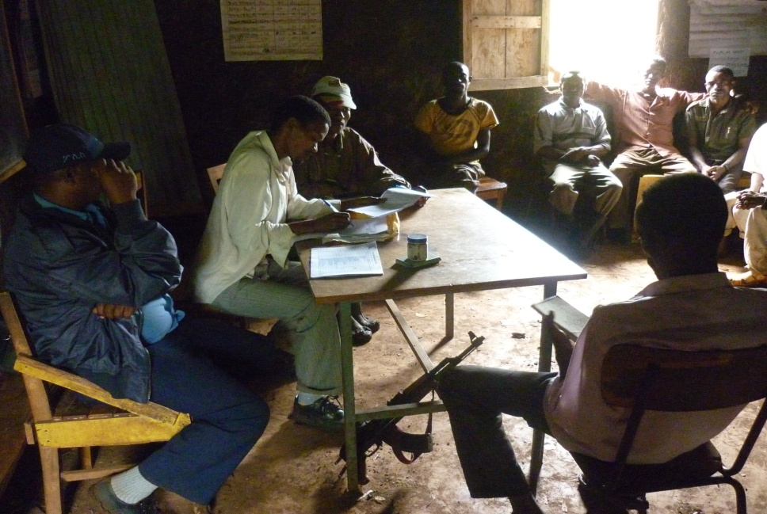

Police and Kebele officials discussing with people and paying PSNP money

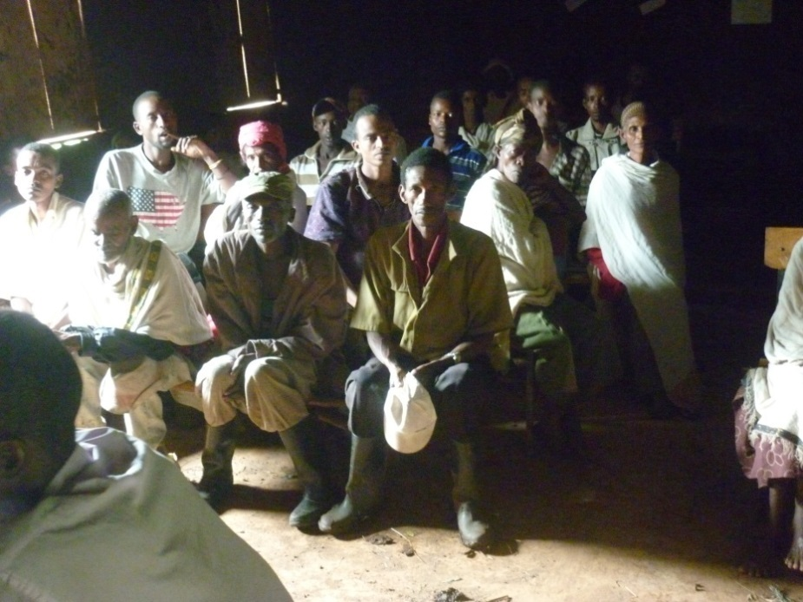

PSNP beneficiaries meeting to discuss and take their money

Case stories

Case story of Mrs. N a potter
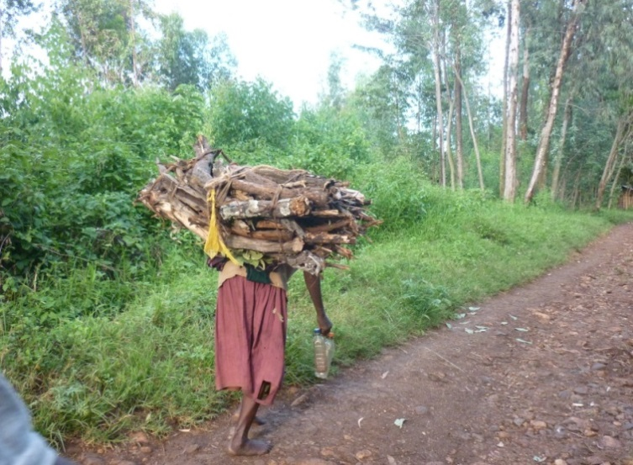
N is one of the potters in Do’oma who has a small size land on which she and five children rely for subsistence. However, the product that comes from farming doesn’t support the family to cover food need throughout the year. To complement the livelihood, N began pottery as an alternative source of earning; she sells her clay works at Wacha and Maze markets as well as by carrying them in the villages in non-market days. Even though she tried hard to support the family, 2011 was a drought season (crop failure due to shortage of rain) and she couldn’t afford to cover food expenses, which forced her to find another source of income, collecting fire wood from the forest and carrying it to Wacha town. I took the picture while she began walking to Wacha carrying the wood that she hoped would bring her 25 birr. As the picture shows, she has got two plastic bottles to buy 1 birr fuel to lighten her at night and one bottle which is sent by her neighbour. She received emergency food aid in 2011, she is part of the PSN Programme.

Mrs. N on her way to Wacha to sell fire wood

Case story of farmer with injured calf
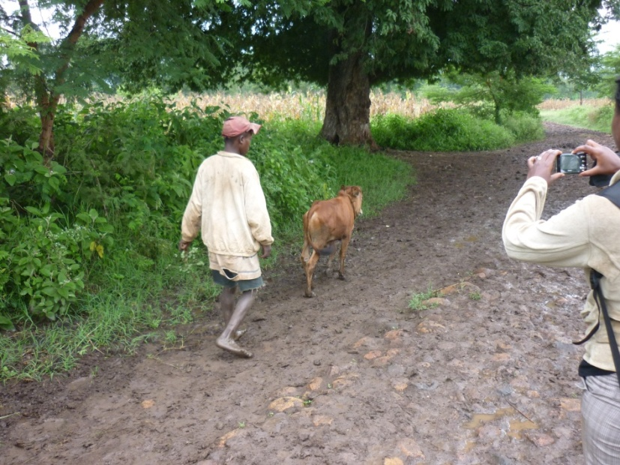
The man in the picture below is a farmer in Do’oma kebele, who is taking his calf to the veterinary service at Wacha. The calf is injured on its rear leg and there is no veterinary service at Do’oma at the moment, even the periodic vaccine and treatment at the kebele is no more available since 2009. This man has to take the calf to follow up treatment for 3 days.

Do’oma farmer, taking his calf to veterinary service to Wacha

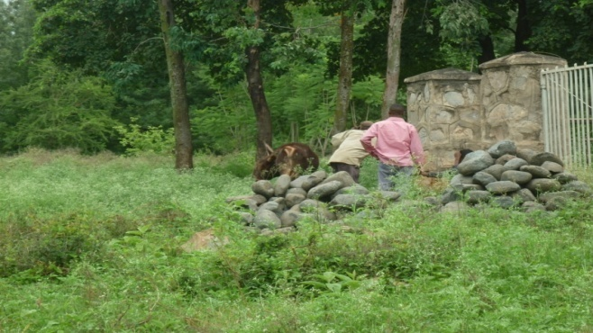 The veterinary at the wereda agricultural office

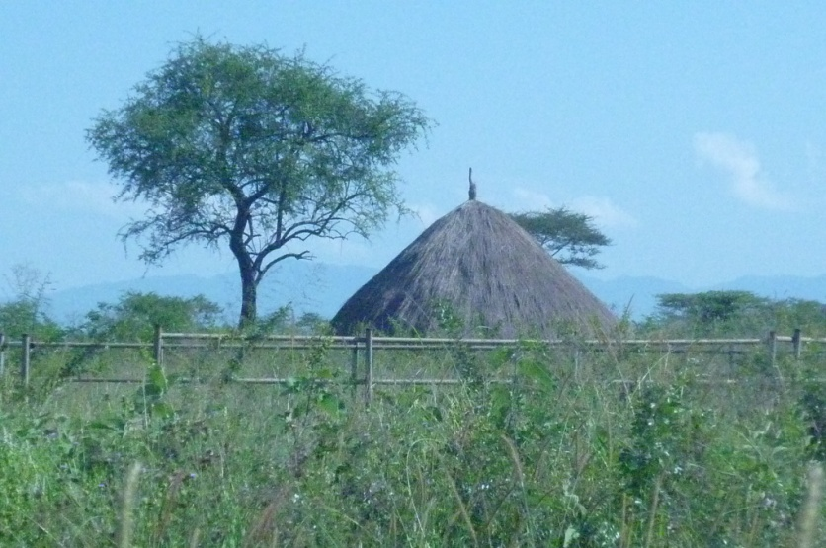
The veterinary service fence at Do’oma that stopped functioning

Cases of use of mobile phones
Since 2009 Do’oma kebele became under mobile network coverage, which created access to the community to people elsewhere. It is mentioned that most of the youth have mobile phones, and respondents estimated about 500 cell phones in the kebele. Some of the respondents who don’t have mobile phones, said that they can access neighbors’ phones at time of serious needs. However, people don’t have electricity to charge their phones unless they travel to Wacha/ to the wereda town. The picture below shows, one of my respondent answering a phone call in the middle of an interview.

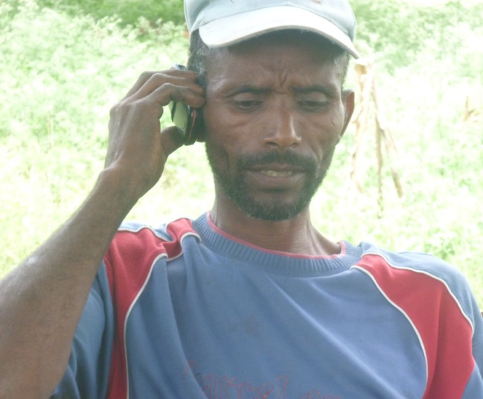
Mr.NT on the phone (Farmer in Do’oma kebele)
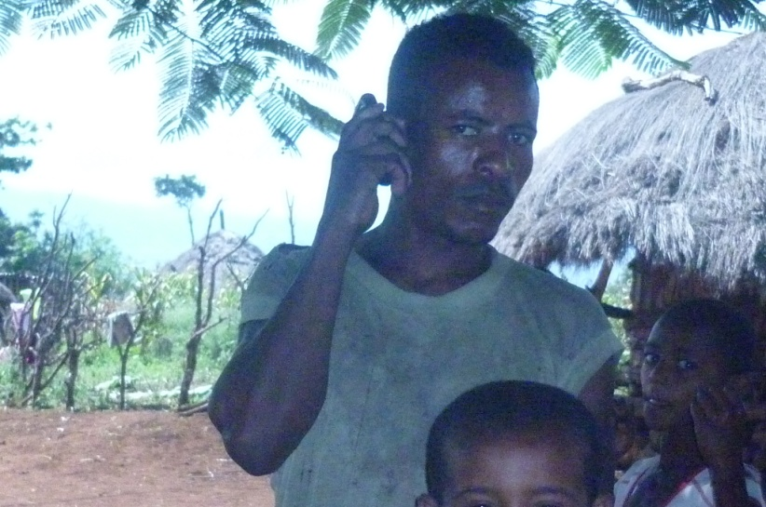
Young man speaking over the phone with relatives away during Meskel at Womala sub-kebele

Meskel Holiday Events
In Sept 29 2011 a Meskel festival/bonfire is celebrated nationally among Christian believers. We were attending the ceremony in Wacha/ Deramalo wereda in front of Debre Genet St. Mary Church where the religious festival and the bonfire took place. Women, children, men, priests and singing group were there on the occasion which was colourful as shown on the pictures below.

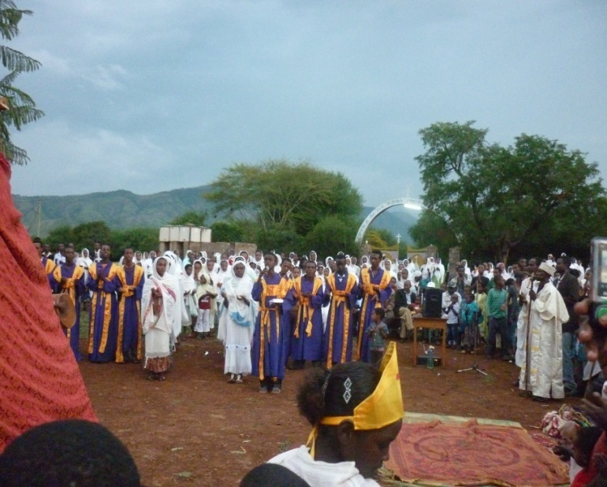

Songs before the bonfire
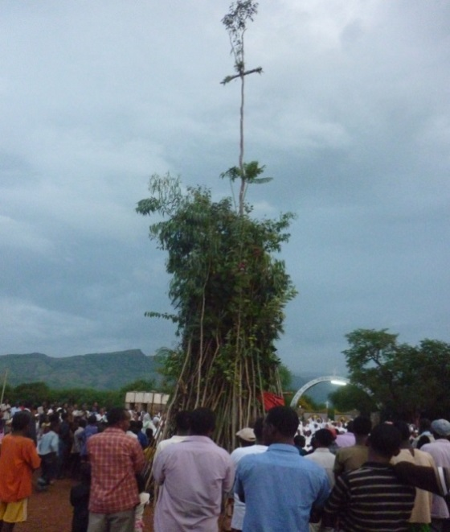
Bunch of sticks and leaves pre-pared for Meskel bonfire
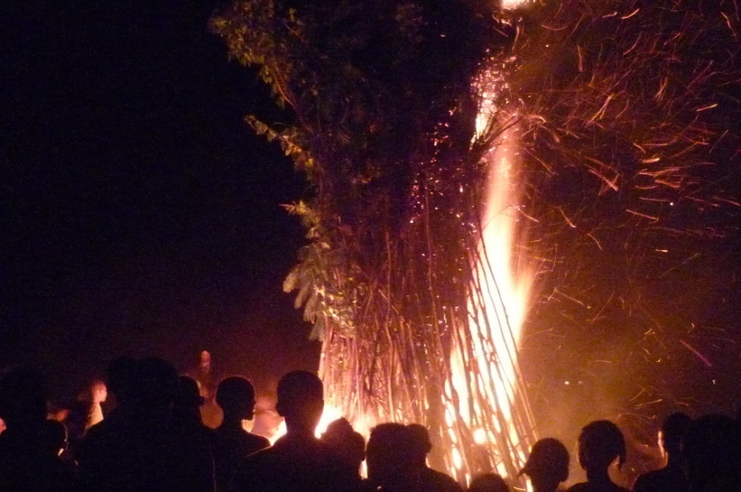
The bonfire surrounded by the crowd

Research officers’ experience of the celebrations
While attending the festival described above we met road construction workers who gave us a ride on their construction truck and who later became friends. They told us as that the Wereda administrator had seen the progress of the bridge at Domba river which pleased him very much so that he brought the big party. The party was funded by the wereda administrator to be celebrated in the hotel that we stayed in. Luckily enough we were also invited to the dinner party to have our share from the goat slaughtered and drinks of our choice. The party was aimed at congratulating the good job, and providing holiday invitation to the construction workers who are away from their families. The construction workers represented one among them to thank what has been done for them which made them feel at home. Me and my research team member enjoyed the night and wrote this to share the event. Though not good ones , some pictures are attached below.

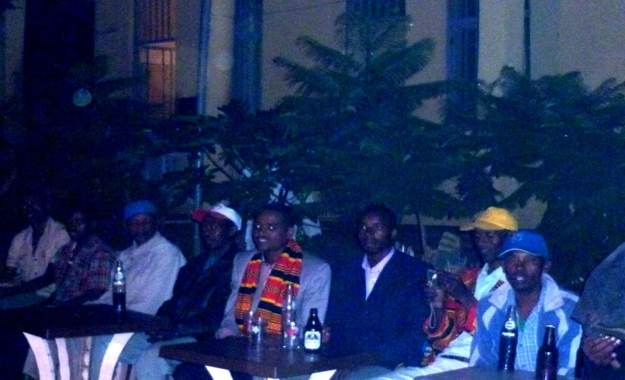
The dinner party with construction workers and invited guests
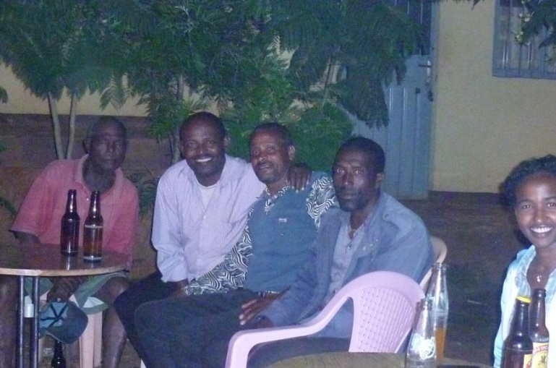

Some of the construction workers
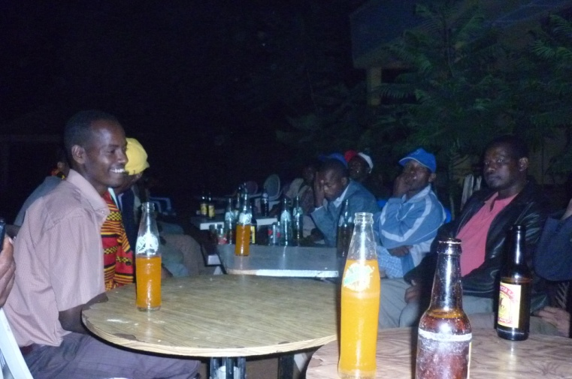
The party from another view

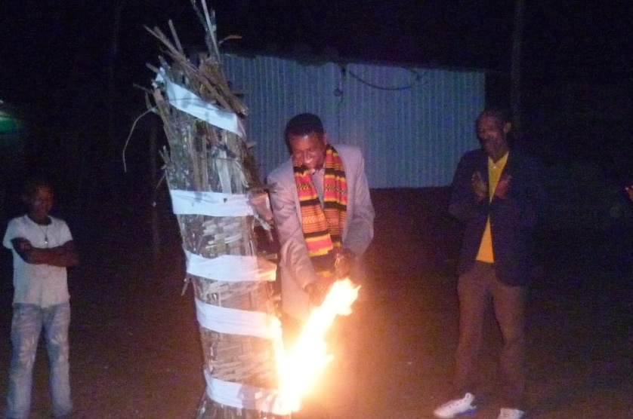
The wereda Administrator starting the Bonfire that he organised for Construction Workers in a hotel

